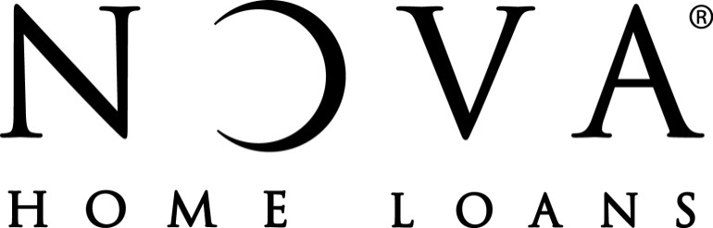

FOR IMMEDIATE RELEASE NOVA® Home Loans
For more information contact:
Kym Adair
520.202.4113

PAUL VOLPE OF NOVA HOME LOANS NAMED THE #1 LOAN OFFICER IN THE COUNTRY FOR 2016

Tucson, AZ (APRIL 27, 2017) --- NOVA® Home Loans, a Tucson based mortgage lender, announced today that Paul Volpe has been named the #1 Loan Officer in the United States based on number of units closed in 2016. Mortgage Executive Magazine and Scotsman Guide, top mortgage industry publications, both independently recognized Paul Volpe as closing more loans in 2016 than any other Loan Officer in the country. Volpe closed 1440 loans to capture the #1 ranking. Volpe is a Senior Vice President, leads the Volpe Team at NOVA Home Loans and was previously recognized as the #1 Loan Officer in the U.S in 2013 and was ranked #4 in 2015.

Volpe noted, “Every year the Volpe Team sets the goal of being #1 in the country. Only through teamwork, dedicated focus on ensuring a high-quality loan experience and wonderfully loyal clients and referral partners have we been so fortunate to reach this goal twice in the past 3 years.” Volpe continued, “I may be biased, but I have the best team of mortgage professionals in the industry working on the Volpe Team and we work for the best mortgage company in the country. Without both of these key pieces, we would not have seen the success that we enjoy today.”

NOVA® Home Loans was founded in 1980 in Tucson, AZ and currently has 19 active branches throughout Arizona, Colorado and Nevada. NOVA® was recently named one of 2016’s Top 100 Mortgage Companies in America and one of 2016’s 50 Best Companies to Work for by Mortgage Executive Magazine. CEO, Jon Volpe, and President, Ray Desmond, were named among the Top 100 Most Influential Mortgage Executives by Mortgage Executive Magazine. BK#0902429, NMLS#3087, Volpe NMLS#48278

